Christmas in a shoebox 2015

What is the project about?

We support the organization ‘Geschenke der Hoffnung’ (https://www.geschenke-der-hoffnung.org/) The project consists of packing a shoebox with clothes/school items/hygiene articles/some sweets and a toy (all items must be new) for a poor child in Europe. Last year our parish’s 165 (!) boxes wend to Romania and Moldavia. The children in certain areas of those countries live in extremely poor conditions. Many of them grow up with their grandparents and hardly see their working parents. Hence, by packing a box, you can help them meet certain basic material needs (toothbrush/toothpaste, warm clothing…) but you can also make a child very happy, who hardly ever receive anything new, let alone a gift!
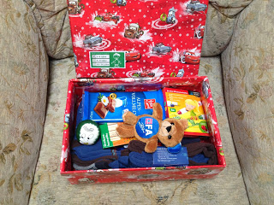 | 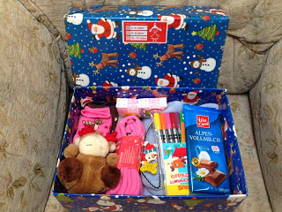
Sample box for a boy aged 5-9 | Sample box for a girl aged 2-4

How can you contribute?

Last year, our parish collected 165 boxes! Let us see how many we can collect this year.
There are different ways you can contribute:
- You can pack a shoebox (please see attached packing guidlelines). Drop the box off at church (Fr Ed or Michele Foley-Rohen) at the latest by October 25th, 2015)
- We will organize ‘packing parties’ at the church, after mass, on the 10/11th and 17/18th October. Here you will be able to buy all necessary items and pack your box on the spot.
- You can knit or crochet hats/mittons/scarves or sew pencil cases.…
- You can also donate money and we will pack a box for you.

Questions?

Do not hesitate to contact Michele Rohen (Michele.foley@cross2.lu , tel 661 838 838) or Father Hone if you have any questions. THANK YOU.

