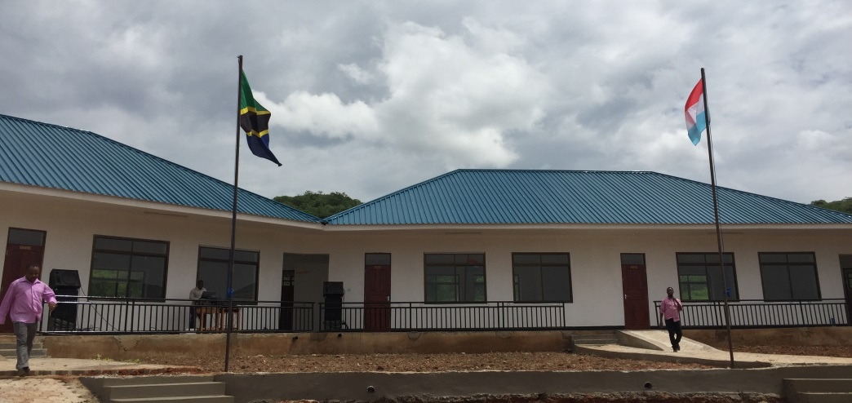

Sunflower Primary school opens in Ilula!
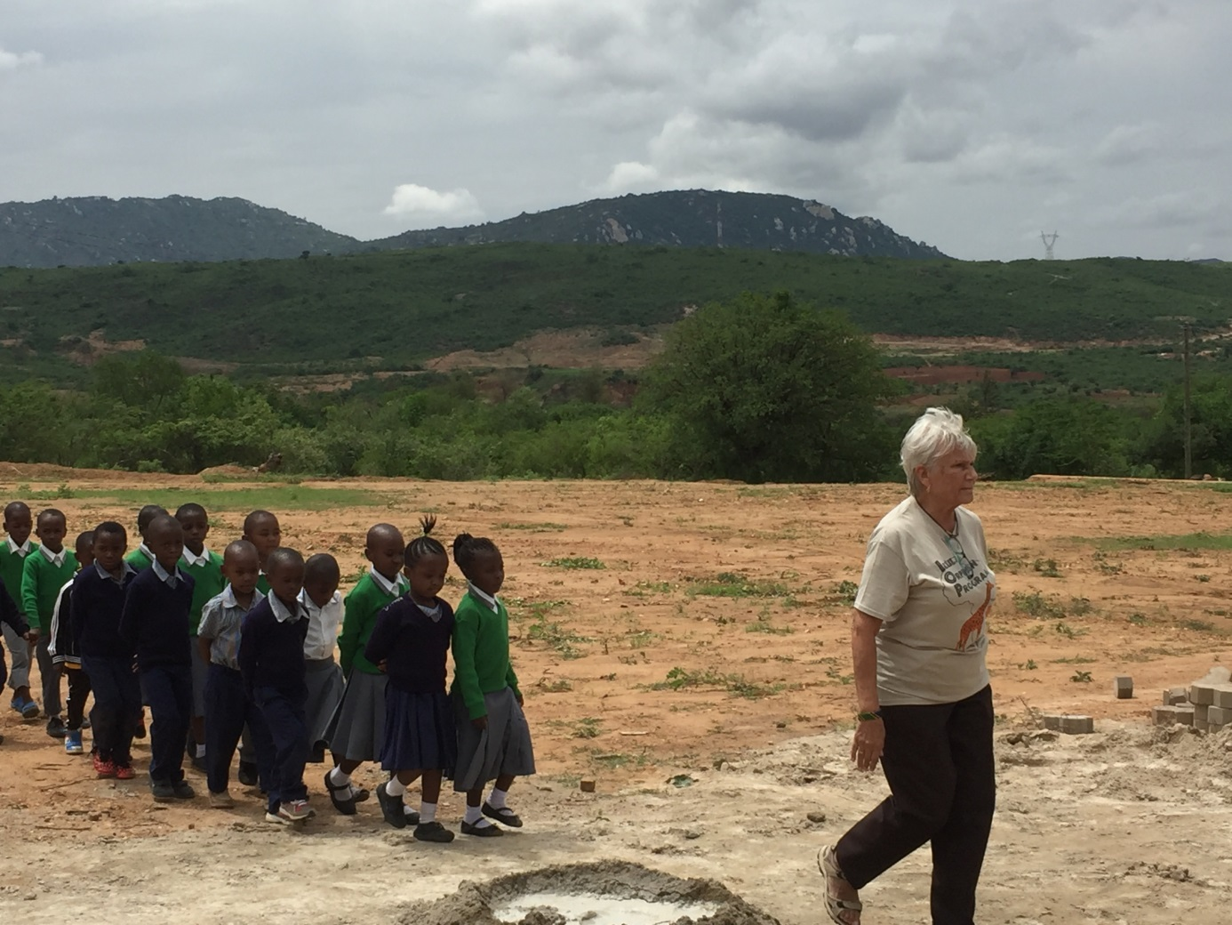

The Sunflower Montessori directors travelled to Ilula in Tanzania last week to witness the inauguration of phase one of the primary school at the Ilula Orphan Program, who decided to name the school “Sunflower”. This first phase has six classrooms and 8 more will be ready at the end of this year. The school will have places for 560 children and will truly change the path of their lives forever. This is the fruition of 7 years of fundraising and Sunflower Montessori and the IOP Luxembourg committee would like to thank all who have supported this project. The children at Sunflower Luxembourg supported their friends in Africa by baking biscuits and recording songs on a CD to sell to their mummies and daddies. The parishioners of St. Alphonse who have donated refreshment money. Many people have attended the (very popular) annual table quiz at The Black Stuff. We have had lots of sponsors for running, cycling and swimming and many private donations. Many people have enjoyed listening to the band “Alizeti” who sing simply for donations. The ceremony took place on Tuesday January 16th , the sun shone and spirits were high. In attendance were the new students who delighted us all with a song about a Sunflower. 
Their new uniform was revealed and is hand in the centre by the sewing ladies. 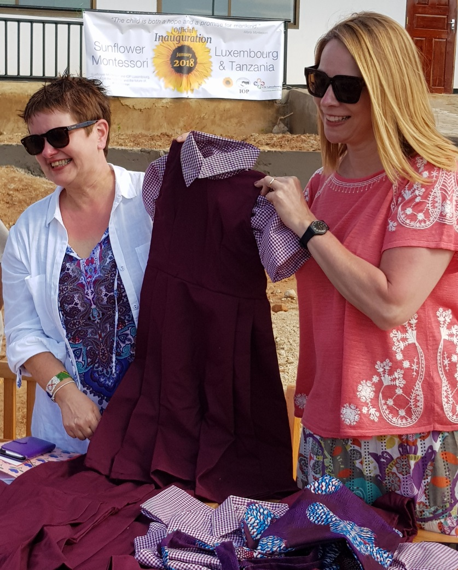
The three Sunflower directors Helen Clarke, Tom O’Dea, Sam O’Dea and senior Manager Ellen Okkerman were proud to help this dream come true for Berit Skaare IOP founder, Edson Msigwa MD and all the IOP staff and teachers. 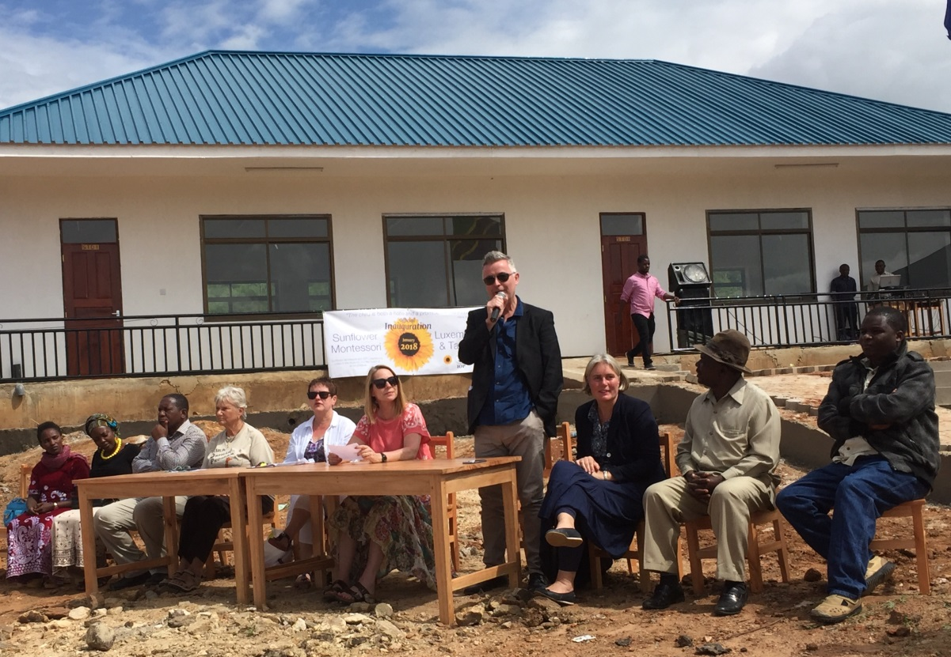
An important part of the ceremony was to raise the flags of Tanzania and Luxembourg, especially poignant as the project was co-funded by the Luxembourg government with the co-operation of CSI. Another esteemed attendee was the Tanzanian government inspector who came to hand over the official registration certificate to allow the school to open. The ceremony ended in great celebration with a dance by the IOP staff and the cutting of a Sunflower cake which the children thoroughly enjoyed!
IOP Luxembourg are delighted to announce the next project “Farm For the Future” more details to follow soon. If you would like to change the life of a child in Tanzania by sponsoring please contact helen@sunflower.lu or Ellen.okkerman@sumflower.lu

