The English-Speaking Community of the Parish of Notre Dame
and the
Anglican Church of Luxembourg

Invite you to join a

Lenten Week of Guided Prayer, 10th to 16th March
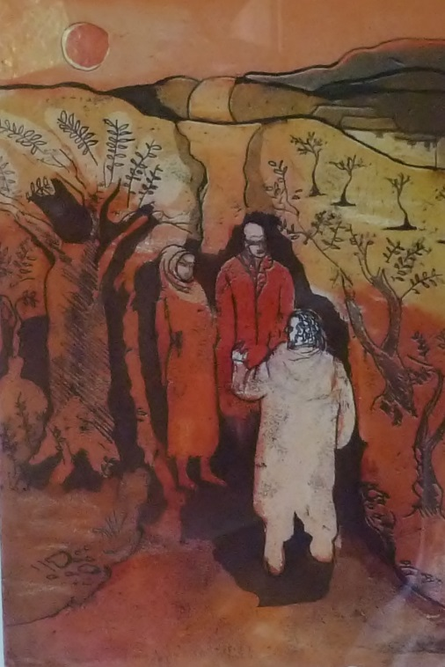
This is an opportunity to:
- learn more about different aspects and practices of prayer
- deepen your personal relationship with God
- share you own concerns, uncertainties and experiences of prayer in confidence with a visiting trained ‘prayer guide’

Sunday evening 10 March at 18.00 - Opening Session
Monday to Friday - daily half hour of personal prayer and opportunity for an individual meeting with a ‘prayer guide’ at times to be arranged. (Other ‘open’ evening sessions may also be offered)
Saturday evening 16 March at 20.00 - Closing Session:
All sessions and meetings will take place at
the St Alphonse Monastery in rue des Capucins.

For further information and to register interest please contact Steve McCarthy before 1st March.

What is Individual Guided Prayer?

We encourage you to pray for 20-30 minutes each day, and then meet at a pre-arranged time each day with your guide to share whatever may be happening in that prayer. Do not worry if it feels like you have very little to report; sometimes prayer seems to go well and sometimes not. Whatever happens or does not happen in the prayer, you might like to take some notes afterwards and bring these to your meeting with your guide.

Sessions with the guide would typically be for 30 minutes but only stay as long as you need. These meetings are not counselling or therapy but an opportunity to explore where God is acting in your life and to help you notice this more deeply. The guide is a person like you who knows what it is to have ups and downs in life and prayer. He/she will listen attentively and lovingly to you and God’s Spirit in you and may then offer suggestions for your ongoing prayer journey.

All sessions take place in strict confidence.

About the image

This painting, by Paul Cyr, is of the meeting between Christ and two disciples on the road to Emmaus after his resurrection (See Lk 24:13-35). It shows the possibility of having a personal relationship and conversation with the risen Christ – an opportunity which God offers to us all through the medium of prayer.

